**Evidence for Implementation and Testing Unit.**

Your name here

Your Cohort

Date here

**I.T 1- Demonstrate one example of encapsulation that you have written in a program.**

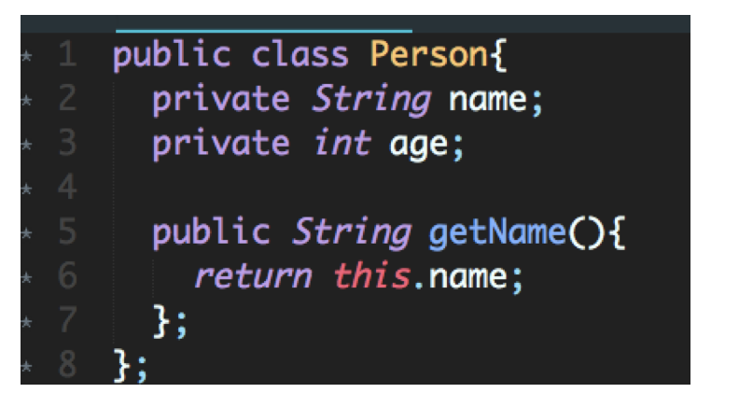

**I.T 2 - Example the use of inheritance in a program.**

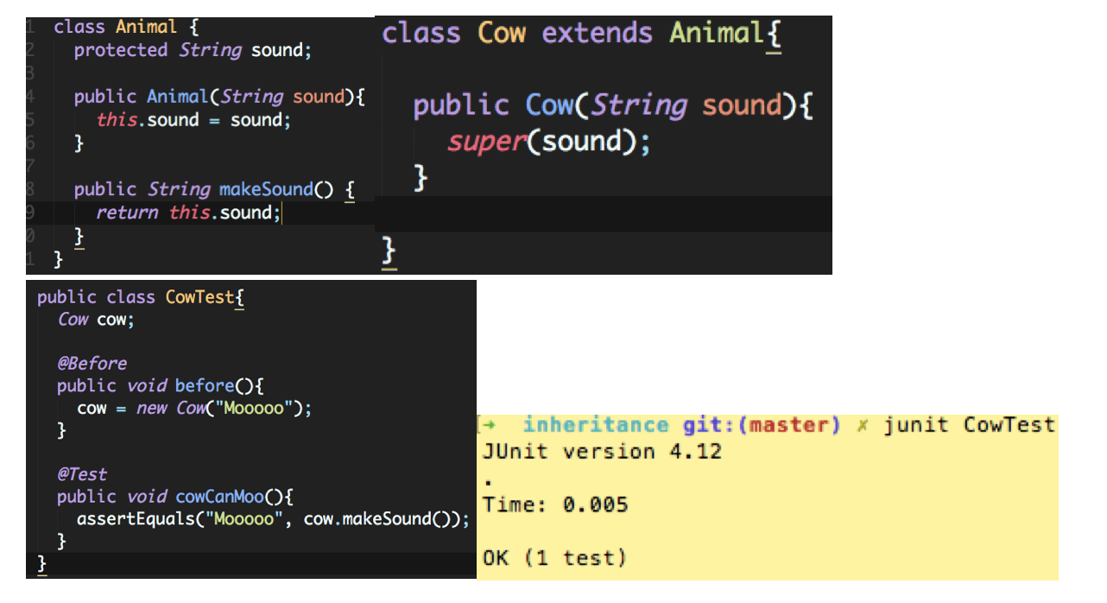

**I.T 3 - Example of searching**

(if you do not have a search and sort algorithm, write one up, take a screenshot. Remember to include the results as well.)

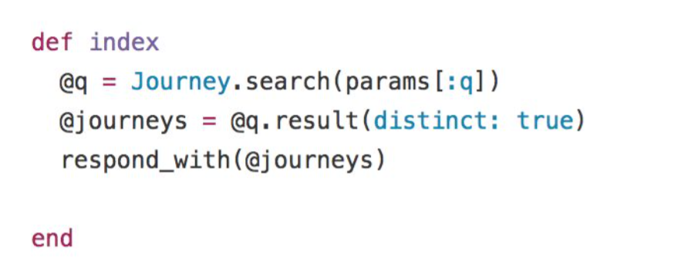

**I.T 4 – Example of sorting**

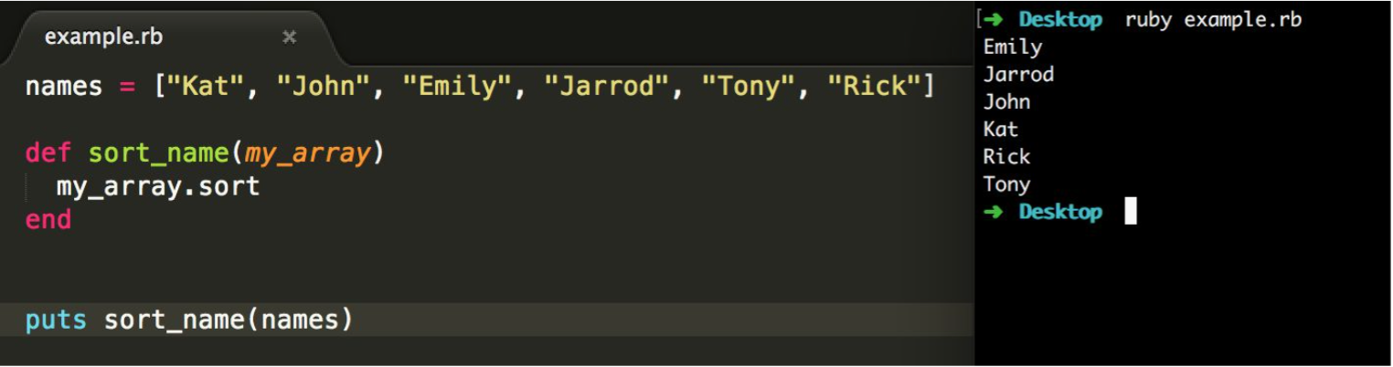

**I.T 5 - Example of an array, a function that uses an array and the result**

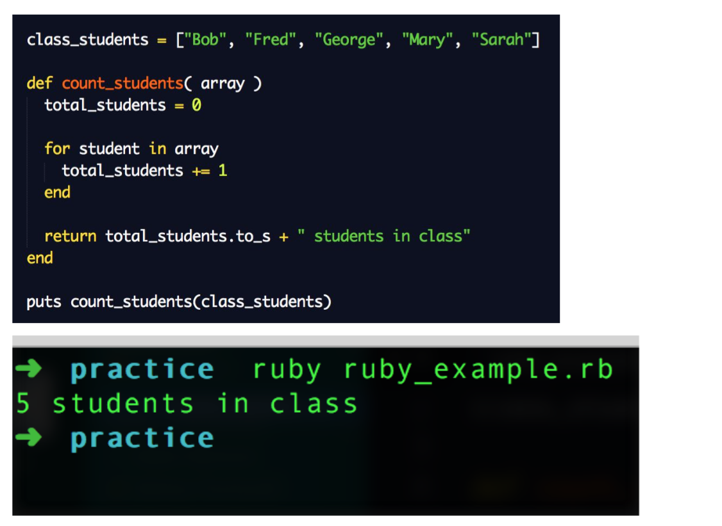

**I.T 6 - Example of a hash, a function that uses a hash and the result**  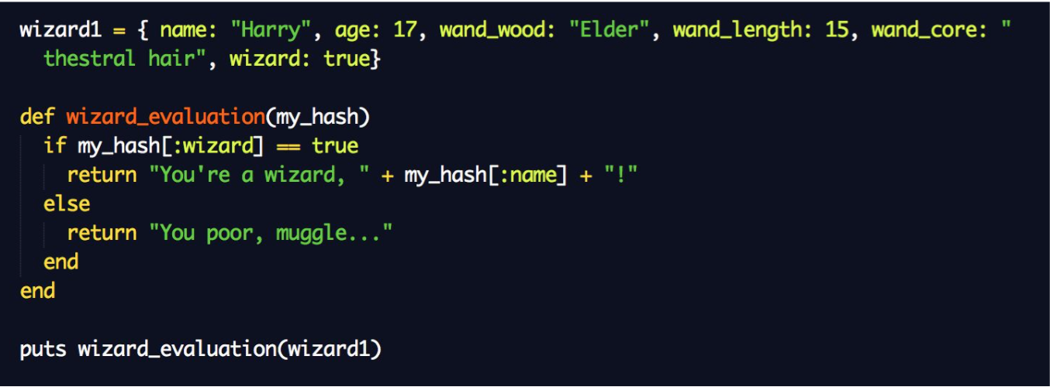

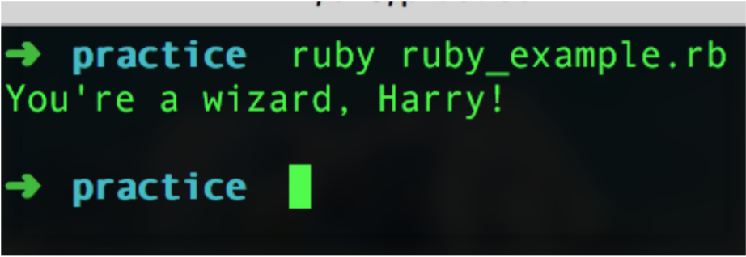

**I.T 7 - Example of polymorphism in a program**

